



**IS480 Project Proposal**

**Stepwise**

**The Grizzly Badgers**

**v1.2 (Not sent to school)**

**11 October 2016**

**Team Members:**

* Christopher Teo Jian Ming ([mj.teo.2014@sis.smu.edu.sg](mailto:mj.teo.2014@sis.smu.edu.sg)) - Project Manager & Business Analyst
* Yu Zheng Yuan ([zyyu.2014@sis.smu.edu.sg](mailto:zyyu.2014@sis.smu.edu.sg)) - Data & System Analyst
* Lam Zhao Yin Aloysius ([aloysiuslam.2014@smu.edu.sg](mailto:aloysiuslam.2014@smu.edu.sg)) - Front-end Developer
* Abdul Shahid Bin Rahmat ([abdulsr.2014@sis.smu.edu.sg](mailto:abdulsr.2014@sis.smu.edu.sg)) - Front-end Developer & Database Specialist
* Ang Zhuang Kai Friedemann ([zk.ang.2014@sis.smu.edu.sg](mailto:zk.ang.2014@sis.smu.edu.sg)) - Back-end Developer & Database Specialist
* Wu Jiawei Jason ([jason.wu.2014@sis.smu.edu.sg](mailto:jason.wu.2014@sis.smu.edu.sg)) - Back-end Developer

**Faculty Supervisor:**

* To be Assigned

**Sponsor:**

* Ang Mo Kio Thye Hua Kwan Community Hospital
  + Mr Damien Tong ([damien_tong@amkh.org.sg](mailto:damien_tong@amkh.org.sg)) - Human Resource Director
  + Mr Edy Chandra ([edy_chandra@amkh.org.sg](mailto:edy_chandra@amkh.org.sg)) - Systems Analyst
  + Dr Jocelyn Koh (jocelyn_koh@amkh.org.sg) - Infection Control Team Lead
  + Ms Sarah Lim (sarah_lim@amkh.org.sg) - Infection Control Team

**Project Overview**

**1.1 Project Description:**

Ang Mo Kio – Thye Hua Kwan Hospital (AMKTHKH) currently possesses a legacy system developed for Visitor Logging known as the “Triage System” which is not currently in use due system incompatibility. The hospital wants to replace this system with one which is more robust and keeps manual recording to a minimum. The Triage System is deployed during states of medical emergency such as the outbreak of a highly contagious disease, to provide a contact list of people who have come in contact with infectious visitors or patients.

**1.2**  **Motivation:**

Due to advancement is technology, the “Triage System” is inoperable on modern devices, making visitor logging impossible via an IT system at present. In addition, the previous system did not log important data such as dwell time and locations of visit within the hospital. This negatively affects the data available for use in contact tracing when an infectious person has been identified. We aim to streamline, simplify and increase tracking so that contact tracing can be more accurate, effective and most importantly, be able to facilitate the overall processes.

Our X-Factor is to accurately register and track 100 visitors within the 2-hour time-frame for the triage exercise.

**1.3 Stakeholders:**

|  |  |
| --- | --- |
| Sponsor | The Infection Control Team and IT/MIS Team will be our main stakeholders in this project. The Infection Control Team will be providing us with Ministry of Health regulations and guidelines as well as a low-down of their processes related to visitor logging and contact tracing. The IT/MIS Team will be providing advice and information on the current system architecture of AMKTHKH. They will also be our primary point of contact from AMKTHKH, for the coordination of meetings and user testing sessions. |
| User | The front desk personnel such as Nurses will be using this system to manage the registration and sign in of visitors. The Infection Control Team will be using this system to access visitor records for contact tracing purposes. Finally, the IT/MIS Team will be maintaining the system, related to the tracking function, and management of passes and visitor records. |
| Advisors/ Practitioners/Mentors | IT/MIS System Analyst, Mr Edy Chandra, will be working with our team with regards to the IT requirements of our project. They will also be our point of contact when it comes to UAT planning, execution and deployment as well as any form of administration matters. |

**1.4 Deliverables:**

*Outcomes*

A Web-based application hosted on a local server managed by IT/MIS, which is able to take in and store visitor information such as personal particulars, medical history, travel history and visit information. The visit information of all visitors will be accessed in events where contact tracing is initiated to identify all visitors who have been in contact with an infected visitor or patient.

*Value Statement*

The sponsor will obtain a web-based integrated solution for visitor logging, more accurate tracking, and seamless contact tracing that can be easily accessed from any device’s browser.

**1.5 Scope:** 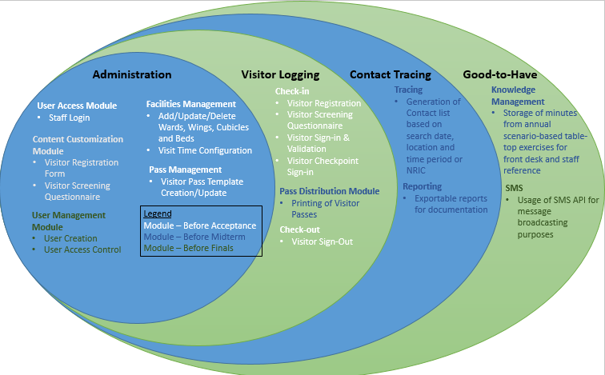

In-Scope Requirements

|  |  |
| --- | --- |
| **Must-Haves** | **Good-to-Haves** |
| * Visitor Logging * Visitor Tracking * Contact Tracing * Administrative configuration functions | * Knowledge Management Function to refer to SOPs or FAQs * SMS System for information broadcast to visitors or staff |

Constraints

* Existing Infrastructure at AMKTHKH will restrict the flexibility of programming to .NET architecture.
* Local nature of the AMKTHKH server would limit the time available for on-site testing of the application.

Assumptions

* The data fields and standard operating procedures will be provided by the sponsor for the crafting of the logic of the Visitor Logging and Contact Tracing before the start of the development phase of the project.

**Project Plan**

**1.6** **Project milestone:**



**1.7** **Risks:**

|  |  |
| --- | --- |
| **Risk** | **Mitigation** |
| Potential Difficulty in programming in C# as some of team members are not experienced in C#. | Plan out a timeline to learn & practice programming in C#. Also work with IT/MIS from AMKTHKH on this as they are proficient in .NET programming languages |
| Verification against the Patient Management System when it goes live might fail as we cannot verify against real patient data in the development phase due to data privacy issues. | Set up a parallel identical system in the development server to conduct pre-deployment testing so as to reduce the risk of a live system failure. |
| AMKTHKH management has a budget set aside for the project, but have not confirmed on the solution they want to adopt to be used for visitor tracking within the hospital. | The team will submit a proposal detailing the solutions and cost breakdown to the Mr Edy Chandra by 17 Oct who will present the solutions to the hospital management. The team will develop non-related modules first, such as administrative modules and visitor registration.  The hospital also has hardware such as barcode scanners which have already been procured for the old Triage System. The team will fall back to these hardware, should no budget be approved. |

**1.8** **Resource and references:**

|  |  |
| --- | --- |
| **Training/Library Requirement** | **Source/Training IC** |
| JIRA Project Management Tool | Christopher Teo |
| Git Repository Version Control Methodology | Friedemann Ang,<https://help.github.com/articles/using-pull-requests/> |
| .NET (C#) | Shahid Abdul Rahmat |
| HTML/CSS/Javascript | <http://www.w3schools.com/> |